Chapter 5 web project

1.topic

* The purpose of my website will be to assist anyone with nutritional questions related to general fitness such as how to structure your diet for weight loss/ gain/ maintenance.
* I am creating this website to coincide with a similar fitness related website that my brother had created and to help others become more knowledgeable with general fitness.
* My overall goal for the website will be to provide a basic understanding on nutrition and how to structure a proper diet for your goals as well as good habits such as “intuitive eating”
* My end goal is to have a website that offers the user the ability to calculate their body mass index as well as an estimation for daily calorie intake, along with a separate informational section and FAQ section to offer as much information regarding the topic as possible to include a citation page that lists helpful and reliable sources of information surrounding the topic.
* My target audience is anyone of all ages curious about weight loss/ gain/ maintenance or anyone who has general questions about their day to day nutrition.
* My website will address the issue of misinformation surrounding the topic of general fitness and nutrition as well as providing a fundamental understanding of how to go about structuring their eating habits.
* My website will include various photos of whole foods as well as the food pyramid, I will more than likely include the use of an API to assist in this and maximize my productivity.
* [URLs for 2 or more similar sites go here]

2.Hierarchy

(The site map is relatively shallow to maintain simplicity for users)

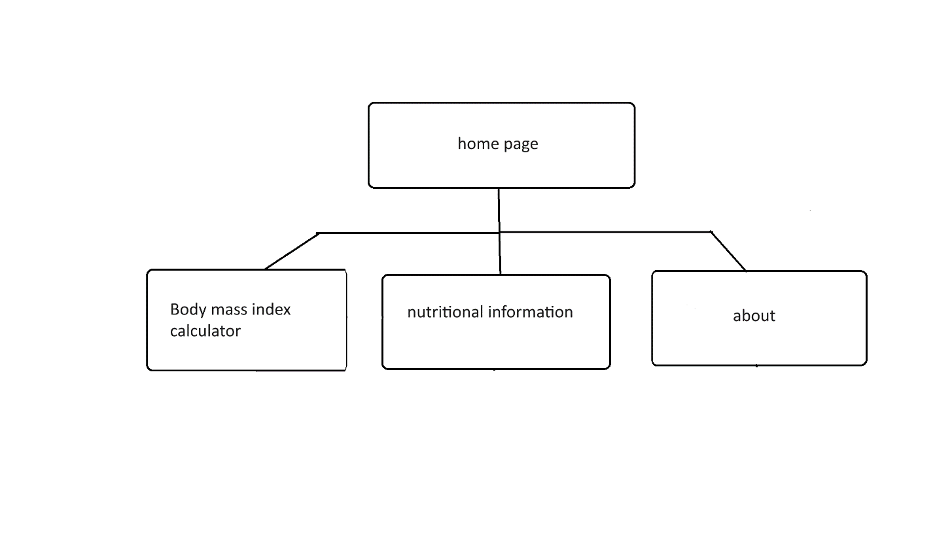

3. page layouts

Home page:

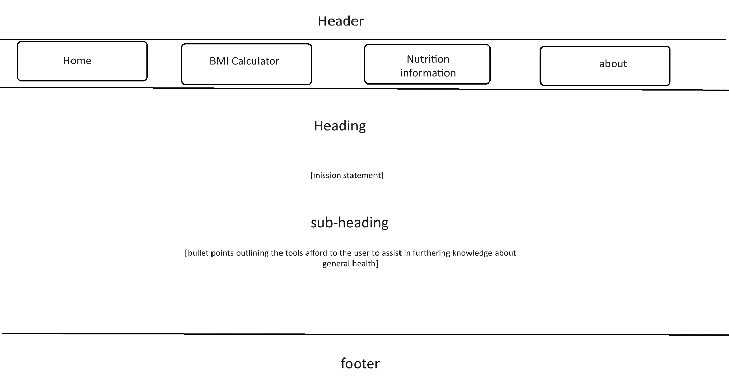

BMI calculator:

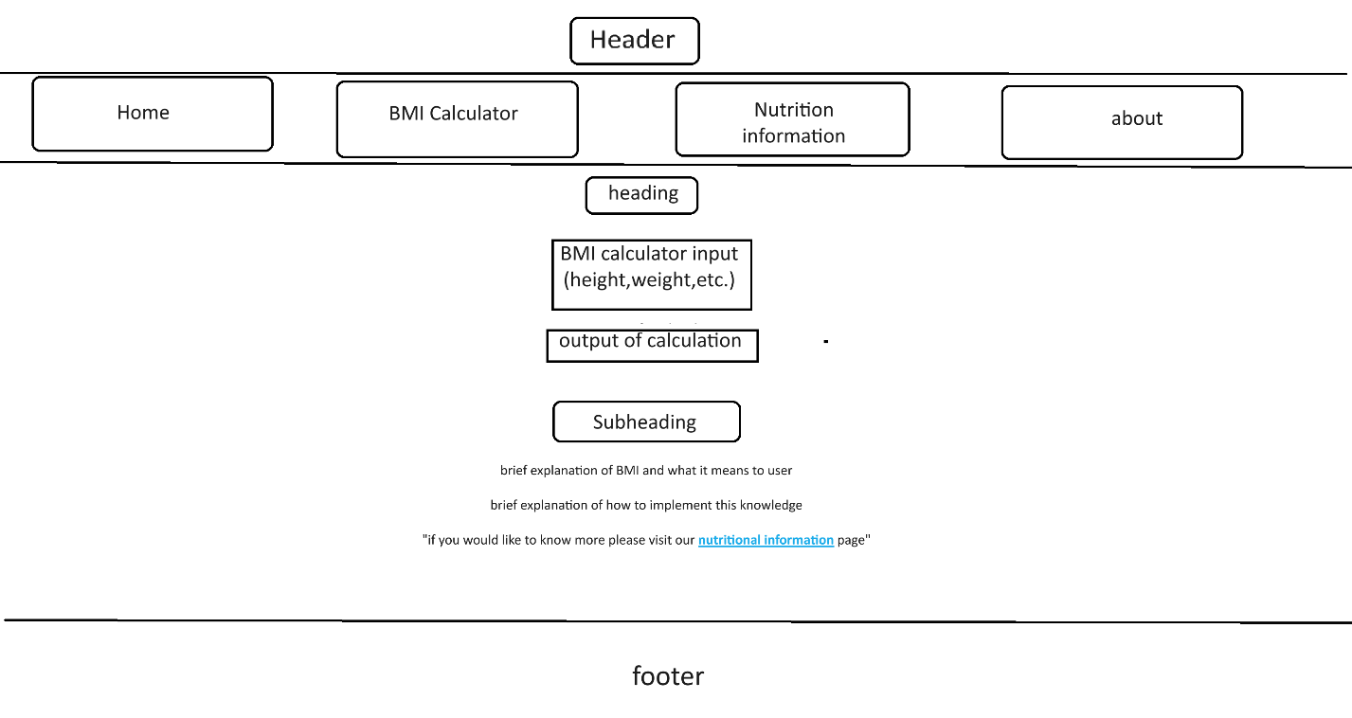

Nutritional info:

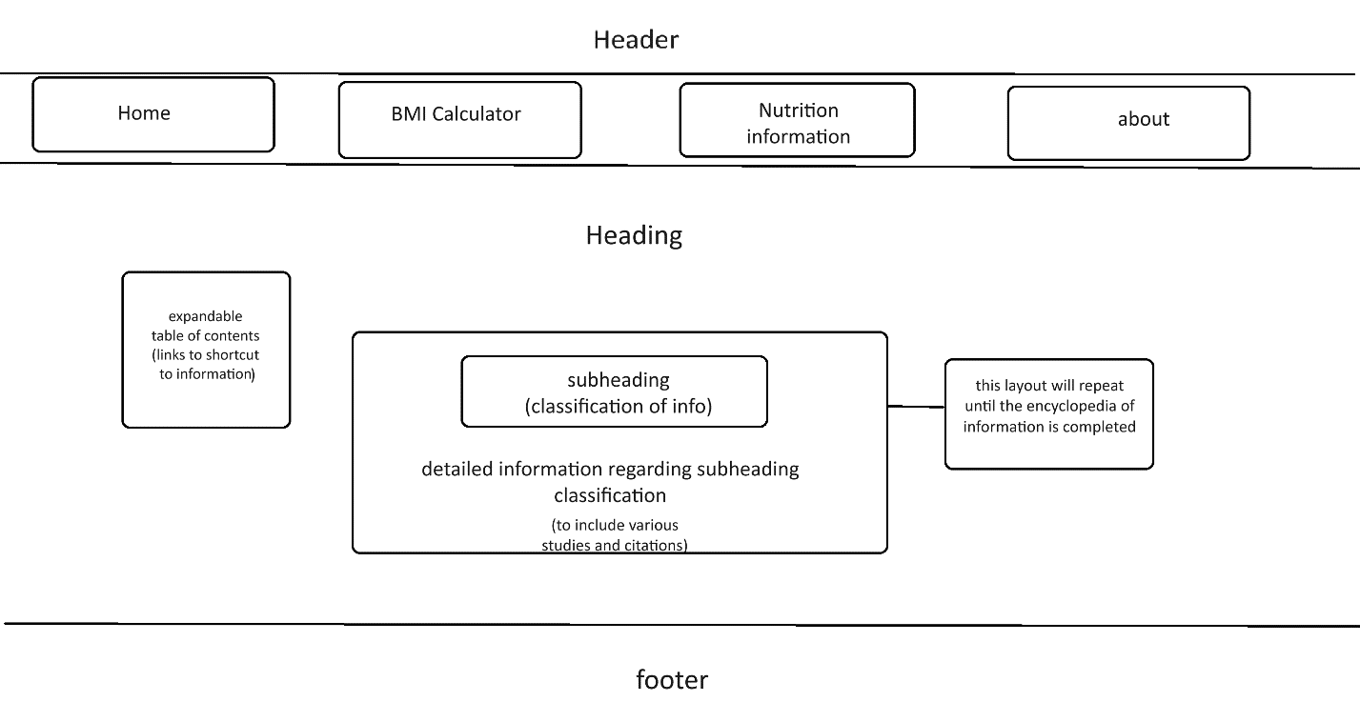

About section:

